dProposal for NEEDLE AND THREAD Emoji
Submitted by: Amanda Hickman, Amberley Romo
Date: July 1, 2017

Abstract
We are requesting the addition of a NEEDLE AND THREAD to the emoji character set. Though the making, mending and wearing of textiles is a defining distinction of human society the current emoji character set includes no sewing or textile related emoji. The NEEDLE AND THREAD fills a notable gap in the tools category.

Introduction
Clothing, virtually all of which incorporates some amount of sewing in its construction, is a defining characteristic of human civilization, and yet we have no emoji for SEWING. Humans are the only animal species that constructs and wears clothing. Not only did clothing allow our pleistocene ancestors to migrate to north into colder climates, but by the time we began to organize ourselves into societies, distinctions between clothing were integral to our community identities, from Scottish clan tartans to Native American bead work.

Though the emoji character set includes glyphs for a number of tools: 🔨 🔧 and 🔩, there are no glyphs for the making, mending, or maintenance of textiles. Notably, the available tool glyphs are all strongly associated with trades traditionally dominated by men (carpentry, construction, maintenance of machines). Though cobblers and tailors and sail makers make heavy use of the needle and thread, in many cultures sewing remains strongly associated with women.

Alongside the YARN, SAFETY PIN and SPOOL OF THREAD proposals, this is one of several sewing and fiber arts proposals that fill a notable gap in the character set.

History
The oldest known sewing needle is 50,000 years old and predates homo sapiens. Ancient Egyptians made ceramic needles, Romans made bronze and iron needles. The ancient Indian Vedas describe the care and use of steel needles for medical purposes. We've refined the design a bit, and we produce needles in a wide range of sizes, but the basic design of the needle pulling thread has not changed.

A threaded needle is used to stitch leather shoes, canvas sails, delicate silks, cotton shirts. It is used for decorative embroidery work, quilting, tatting lace, darning stockings, applique, cross-stitch, beadwork, and making tapestries. The Japanese tradition of sashiko (or 刺し子) uses a needle and thread, as does Korean bojagi (보자기). Countless Native American tribes decorate day-to-day and ceremonial clothing with carefully sewn beadwork.

Names
(Suggested short name and keywords, as in the Emoji List).
- NEEDLE AND THREAD
- SEWING | MENDING | QUILTING | TAILORING | STITCHES | SUTURES | EMBROIDERY

Images
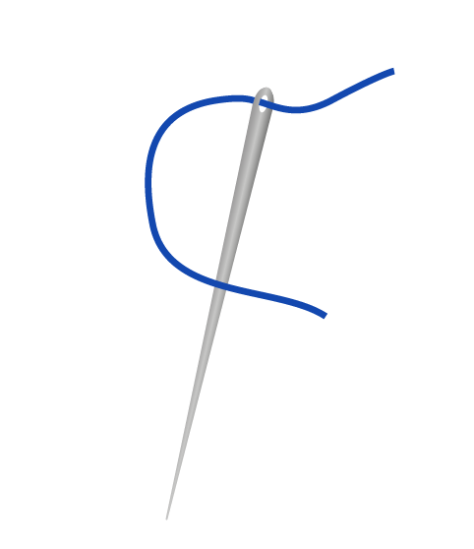
Artwork created by Cherin Sanih

Selection Factors Inclusion

A. Compatibility
We are not aware of an existing NEEDLE AND THREAD emoji or icon.

B. Expected Usage Level

Frequency
There is no where in the world where people don't make and mend clothing, bedding, luggage, and decoration by sewing. Mass production happens on sewing machines, but everywhere high end couture sewing and tailoring happens with a simple needle and thread, as does mending and tailoring. Nearly 5 million Instagram posts use the #sewing hashtag and another 4 million are tagged #embroidery. Just shy of 800 thousand are tagged #quilting. These are just a few of the many, many crafts and pursuits that require a needle and thread.

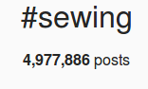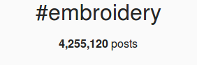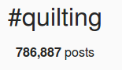

Multiple Usages
Sewing, quilting and embroidery are by no means the only use for the NEEDLE AND THREAD.
A surgeon uses a NEEDLE AND THREAD to suture a wound. The needle and thread is essential to taxidermy, upholstery, and book binding. Sail makers use a needle and thread to bind canvas. Hikers use a needle and thread to lance blisters.

The finest couture ball gown is hand sewn, as is a patch that keeps a worn pair of jeans in service a little longer.

Symbolically, a needle and thread can represent finery (couture, embroidery, fine tailoring) as easily as it represents resourcefulness and conservation (mending and repairing clothing and other textiles, rather than discarding and replacing them).

C. Image Distinctiveness
A threaded needle is unmistakably that. Though a simple glyph might represent a wide range of thread and needle sizes, it is unlikely to be confused with any other emoji.

D. Completeness
The NEEDLE AND THREAD fills a notable gap in the available emoji to represent tools, making, crafts and art. It is both versatile and vital.

E. Frequently Requested
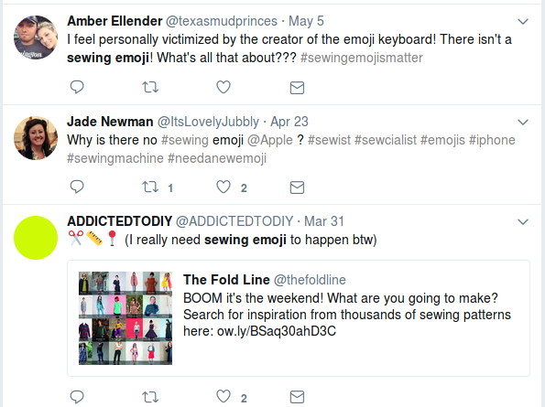
Sewing and Knitting were among the top emoji requests on Emojipedia in 2016 and 2017.
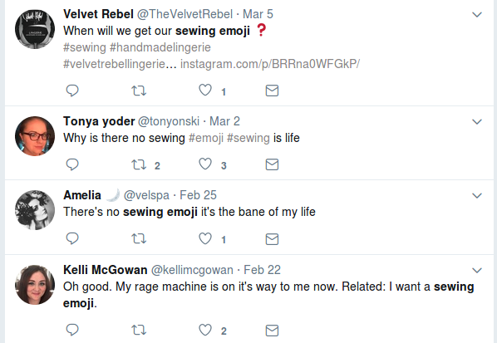

Selection Factors Exclusion

F. Overly Specific
A sewing needle has broad application, and the design of a needle is universal, worldwide. A large needle can pull leather cording through a canvas sail, a tiny needle can pull fine thread through finer silk. But they all share the same basic form, and a single glyph can capture both large and small. Throughout the world for tens of thousands of years humans and our precursors have used a threaded needle to make and mend.

G. Open Ended
We are proposing several sewing and textile related emoji: the SAFETY PIN, THREAD SPOOL, and KNITTING, but we do not believe that the addition of these core textile tools opens up a new category of emoji.

H. Already Representable
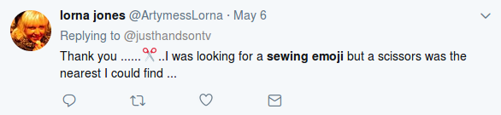
There is no existing emoji that approaches the sewing needle. ➰ and ➿ are sometimes used to represent string or thread. The pin and scissors are used in sewing but appear as often as a gripe about the inadequacy of the current emoji character set:
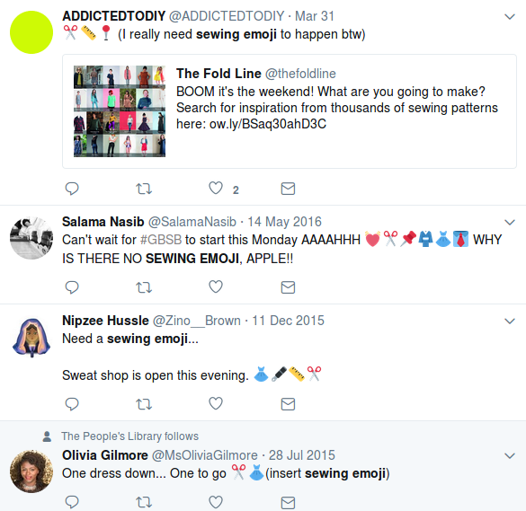

I. Logos, brands, UI icons, signage, specific people, deities
The design of the needle is tens of thousands of years old. It is not copyrightable.

The image we are submitting does not have any significance that would make it
unsuitable for encoding as a character. There are no copyright, religious, or issues that
reference anyone historic or living.

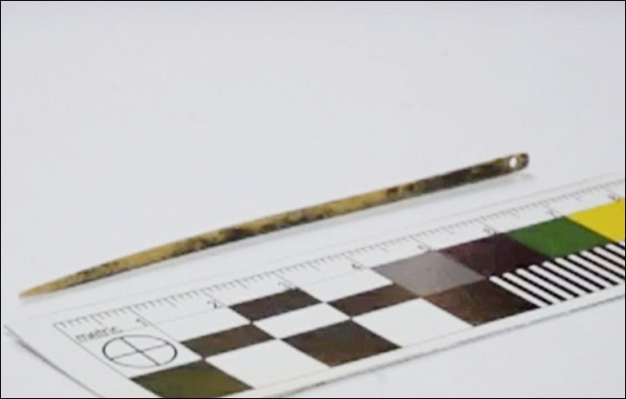
J. Transient
The 50,000 year old siberian bone needle bears a striking resemblance to a modern sewing or tapestry needle. Humankind shows no sign of abandoning sewing by needle.

K. Faulty Comparison
There is no existing sewing emoji.

Sort location
(Proposed sort location for the emoji in Emoji Ordering)
- Object-textiles, after tool and before medical

Other Information

Author Bios (optional)
Amberley Romo (amberleyjohanna@gmail.com) is a software developer and avid knitter. Amberley grew up (and currently lives in) Texas, and has been very involved in the fiber arts communities of both Washington, DC and Austin, TX. She is passionate about knitting as a meditative practice, and community activity.

Amanda Hickman (amanda@velociraptor.info) runs a fellowship program that helps creative technologists collaborate with journalists on storytelling and audience engagement projects. She has been sewing since she was six years old, and cherishes the independence afforded by mending, altering and making her own clothes. She is currently working on patching a pair of jeans and tailoring a blazer.

Character Properties
The other character properties are suggested to be defined as follows.
General Category:
Canonical Combining Class:
Bidirectional Class:
Decomposition Type:
Decomposition Mapping:
Numeric Type:
Numeric Value:
Bidirectional Mirrored:
Name:
ISO Comment:
Simple Uppercase Mapping: Simple Lowercase Mapping: Simple Titlecase Mapping:

https://en.wikipedia.org/wiki/History_of_clothing_and_textiles#Prehistoric_development
http://siberiantimes.com/science/casestudy/news/n0711-worlds-oldest-needle-found-in-siberian-cave-that-stitches-together-human-history/
http://fashion-history.lovetoknow.com/fashion-history-eras/history-needles-sewing
http://blog.emojipedia.org/top-emoji-requests-2016/
http://blog.emojipedia.org/top-emoji-requests-2017/

